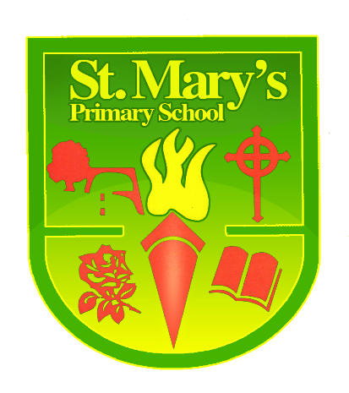

St Mary’s Primary School Policy and procedures for the treatment of Head lice
Rationale

The Northern Ireland regional policy for the control of head lice was first introduced on 24 March 1999 and reflects national guidance issued. The Southern trust currently adhere to guidelines issued by the Department of Health and Social Services and public safety (2008)
Head lice are described in the regional policy as a problem of the wider community and not primarily a problem of schools.
St. Mary’s Primary School does, however, recognise that as part of this community it can make a contribution by supporting parents in promoting and maintaining healthy, thriving children.
This policy attempts to set out the duties and responsibilities of parents, the school and the Health Authorities in dealing with head lice. It sets out what school can and cannot do legally as well as providing some practical advice as to how to tackle head lice.
Principles
- Head lice are a problem of the whole community and are passed on by close family members and friends in the home and neighbourhood as well as in school.
- Head lice are transferred by direct, prolonged, head-to-head contact
- Head lice infestation is not a serious physical health problem, however persistent head lice which is untreated is regarded as neglect and therefore could become a child protection issue.
- Clear diagnosis is important - treatment should only be started if a living, moving louse is discovered.
- The main responsibility for the identification of head lice is that of the parents or guardians. They should identify and treat any head lice problem and seek help from their doctor or health visitor if necessary. Further advice is also available on the NHS website http://www.nhs.uk/Conditions/Head-lice/Pages/Introduction.aspx
Parent’s/Carers/Guardians Duties
As the carer of a child you should;
- Undertake regular weekly and where appropriate daily checks to ensure that your child/family is not affected. This should be done with a detector (nit) comb as noted in the advice section. All family members should be checked.
- Inform all contacts of the family / friends who may have come in to head to head contact for a minute or more in the last month
- Seek advice from a medical practitioner (Pharmacist/ Health Visitor/ Doctor about using an approved lotion and treat using this method in the recommended way.*

School Duties
- Provide information about Head lice to help parents detect and treat suspected cases, on an annual basis and more regularly if many cases arise.
- Staff will maintain a visual check on pupils.
- Parents are urged, as in all health matters, to seek diagnosis from a medical professional and to treat the problem immediately for the benefit of the child, family and community.
- Encourage parents to seek advice from a pharmacist or medical professional if they find Head lice to be a problem.

School Procedures
- If a member of staff sees a living, moving louse in a child’s hair every effort will be made to contact the parent on the day and inform them verbally.
- Should we be unable to inform the parent verbally a letter will be sent home. The reply slip should be signed and returned inside two days.
- If no reply is obtained, or if the problem persists, the school nurse will be contacted.
- The nurse may then contact the parents to offer advice and support.
- Information will remain confidential at all times.
- Parents will be alerted via a text and/or letter if an outbreak is noted in their child’s class or year group.
- The school will initiate our safeguarding procedures if a child’s head lice is left untreated*
The school by law cannot
- Carry out physical checks on pupils for head lice.
- Tell parents to keep children away from school because of head lice.
- Exclude a child from school because of head lice.

*If a parent does not treat their child’s head after having been informed their child was observed to have a living louse it will be dealt with as a child safeguarding issue of neglect and the Schools Policy and Procedures of referral to social services will be implemented.

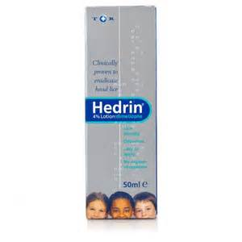
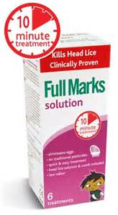
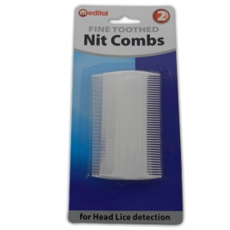
ADVICE
HOW TO PREVENT AND TREAT HEAD LICE
In order to prevent the spread of head lice in school it is important that you check your child’s hair regularly, and if necessary, treat thoroughly with any lotion recommended by a chemist or doctor.
Head lice treatments are available from any chemist free of charge under the NHS Minor Ailments Scheme.
Routine head inspections are no longer carried out in schools but you may find the following information helpful.

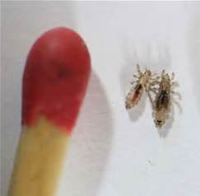
How do you catch head lice?

Head lice cannot jump or fly. They like to live close to the scalp. They are only caught when two people’s heads are in contact for some time.

How do you know you have got head lice?
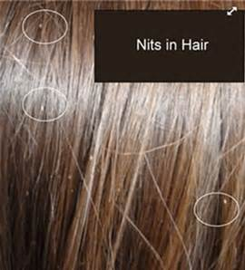
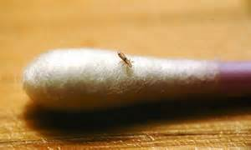
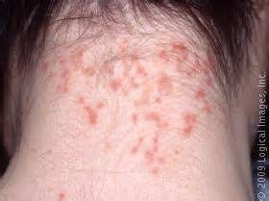

Signs of head lice include: live or dead lice in the hair, nits (empty egg cases), an itchy head, a rash round the neck or ears dark gritty dust on pillows or collars.
A weekly family check for head lice helps prevent infection
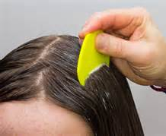
Wash the hair and using a fine-toothed nit comb (available from chemists), comb the wet hair from the roots over a sheet of paper. If nits or eggs are found keep combing every other day for a week to ensure there are no live lice. If one is found, tell those in close contact and begin treatment.
Sometimes head lice return because the treatment was not carried out thoroughly and eggs survived.
Hair should not normally be treated more than twice in three weeks. If the problem persists, speak to the doctor.

*Your child should only be treated for head lice if there is evidence of live louse. Please follow the directions of the Head Lice Treatment carefully.
The NHS website link below has excellent guidance on the prevention and treatment of head lice. It includes a step by step video showing how to wet comb and apply head lice treatments.
http://www.nhs.uk/Conditions/Head-lice/Pages/Introduction.aspx

Facts to equip you for the fight
http://www.thehairforce.co.uk/the-enemy/facts-about-head-lice/
- 53% of people who have them don’t itch and if your child doesn’t itch you probably don’t look. To avoid getting caught out do a weekly check with a nit comb so you can catch them early
- Hairdressers are legally obliged to turn someone away with a nit and lice problem in case they pass it on to their other customers
- Many people mistake dandruff etc for nits. The test is to see if you can easily pull what you find off the hair with your fingers. If it won’t come away easily and is glued onto the hair it is more than likely a nit. They are tear drop shaped and are brownish in colour. If it is clear or white in colour then it has already hatched
- If you want to get rid of nits and head lice you need to understand the life cycle which works like this:
- Many people find that after clearing their child it’s all back 3 to 4 weeks later and this means they must have re-caught them from someone. However what this usually means is that they weren’t fully cleared in the first place. The lice might have been removed but not all the nits and 3 to 4 weeks later those nits have hatched and matured
- To break this cycle you have to keep clearing both the nits as well as the lice out of the hair day after day
- When the products work they will kill the lice, but they won’t necessarily kill the nits. This is why you have to reapply these products 2 weeks later, to catch anything that has successfully hatched since the last treatment. However it is through overuse and misuse that lice have become immune to these shampoos and treatments and 80% of the time they don’t work at all
- The products will not get rid of the nits – there’s no getting away from the workload, these have to be combed out.

